Report Writing

Studies in Multicultural Societies
Prof. Hari Srinivas
Room: I-312
email: hari.srinivas@kwansei.ac.jp

TOPIC: Skills to Work in the United Nations
Report: #2
Type: One-page only
Deadline: Friday, 1 November 2019
Submission: Please submit your report at the end of the class on 10 November. Note that late submissions will not be accepted. All reports should be written within a single sheet of paper, both sides if necessary (single space, 12 point font)
Reference: PPT slides downloaded from http://www.gdrc.info/iep/
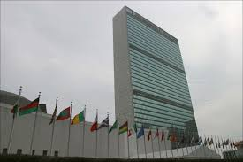
If you want to work in the United Nations you will need three important or “core skills.” These are (1) Integrity, (2) Professionalism, and (3) Respect for Diversity.
The United Nations Headquarters in New York, USA
The third, #Respect for Diversity” is particularly related to the topic of our class, multiculturalism. Specifically, the UN seeks people who have the following skills:

- Works effectively with people from all backgrounds.
- Treats all people with dignity and respect.
- Treats men and women equally.
- Shows respect for, and understanding of, diverse points of view and demonstrates this understanding in daily work and decision-making.
- Examines own biases and behaviour to avoid stereotypical responses.
- Does not discriminate against any individual or group.

What would you do to acquire that skill? How would you use such a skill?

