Report Writing

Studies in Multicultural Societies
Prof. Hari Srinivas
Room: I-312
email: hari.srinivas@kwansei.ac.jp

TOPIC: Why study multicultural societies?
Report: #1
Type: One-page only
Deadline: Friday, 11 October 2019
Submission: Please submit your report at the end of the class on 20 October. Note that late submissions will not be accepted. All reports should be written within a single sheet of paper, both sides if necessary (single space, 12 point font)
Reference: PPT slides downloaded from http://www.gdrc.info/sms/

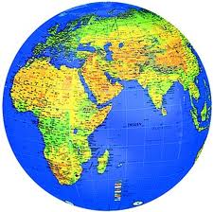
Why study multicultural societies? What kind of skills would it give you? Why is it important to be more "sensitive" to other cultures?
As policy researchers, we need a more comprehensive and complete view of the world to be able to develop good policies. Where does culture fit into this picture? Is it worthwhile to understand different multi cultures? In fact, is multiculturalism good or bad? Is multiculturalism a skill that we should all have to survive in this globalized world?
List out your thoughts on the above issues - the entire report should be on a single sheet of paper, and a hard copy submitted on the bove deadline in the class.

